SIMATS ENGINEERING (SAVEETHA SCHOOL OF ENGINEERING)
Department of Computer Science and Engineering
CO1 ASSESSMENT TOOL 1 – Case Study Analysis
Course Code: | CSA10 / CSA1005 | Course Title: | Software Engineering
CO Assessed: | CO1 | Assessment: | Assessment Tool 1 – Case Study Analysis
Weightage: | 20% | Total Marks: | 25
CO1 Statement: | Apply advanced methodologies and agile project management techniques to manage software projects effectively
Student Name: |  | Reg. No.:
Date: |  | Duration: | 60 minutes

Code of Conduct
I R Divya Dharshini (192573013) (Name / Reg No) certify that this submission is my original work and that I have adhered to the guidelines specified for this assessment. I understand that any violation of academic integrity rules will result in disciplinary action.
Signature of the Student: R Divya Dharshini
Annexure A – Case Study Analysis
Instructions to Students:
Each student will be allotted one problem statement. Analyze the assigned problem systematically by following the steps given below. Your report should demonstrate your understanding of software engineering concepts and your ability to design an appropriate software solution.
Based on your allotted problem statement, prepare a report by answering the following questions:
- Understand the Problem Statement
  - Explain the problem in your own words.
  - Identify the objectives of the proposed system.
  - State the scope of the problem.
- Identify Key Stakeholders and Challenges
  - Identify all the stakeholders involved in the system.
  - Explain the roles and responsibilities of each stakeholder.
  - Discuss the major challenges and issues faced by the stakeholders.
- Analyze the Current Approach
  - Describe the existing system or current process.
  - Identify its strengths and limitations.
  - Analyze the problems or gaps that need to be addressed.
- Propose a Suitable Solution Using Software Engineering Principles
  - Design a software-based solution for the given problem.
  - Describe the major functional modules of the proposed system.
  - Identify the functional and non-functional requirements.
  - Explain how software engineering principles such as modularity, scalability, maintainability, reliability, usability, and security are incorporated into your solution.
- Justify the Chosen Methodology/Framework
  - Select an appropriate Software Development Life Cycle (SDLC) model or software development framework (e.g., Agile, Scrum, Waterfall, Spiral, DevOps).
  - Justify why the selected methodology/framework is suitable for the proposed system.
  - Explain how it supports successful project development and maintenance.
- Discuss Expected Outcomes and Limitations
  - Describe the expected benefits of the proposed solution.
  - Explain how the solution addresses the identified challenges.
  - Discuss potential risks, implementation challenges, and limitations.
  - Suggest possible future enhancements.
ANSWER:
AI-Based Customer Product Recommendation and Comparison System
1. Understand the Problem Statement
1.1 Problem Description
In online shopping, customers are often presented with a large number of products that have similar features, prices, specifications, and ratings. Comparing all these products manually can be time-consuming and confusing. Customers may find it difficult to identify which product best matches their requirements and preferences.
The proposed AI-Based Customer Product Recommendation and Comparison System solves this problem by analyzing customer preferences, product specifications, price ranges, ratings, and previous interactions. The system recommends suitable products and provides a comparison of selected products based on important criteria.
For example, if a customer wants to purchase a smartphone with a budget of ₹20,000–₹30,000, good camera quality, high battery capacity, and a high customer rating, the system analyzes these requirements and displays the most suitable products in ranked order.

1.2 Objectives
The major objectives of the proposed system are:
- To maintain customer preference profiles.
- To store and manage product information.
- To capture product specifications and ratings.
- To recommend suitable products using AI techniques.
- To allow customers to compare multiple products.
- To provide filtering and sorting facilities.
- To track customer interactions and preferences.
- To generate recommendation analytics.
- To reduce the time required for product selection.
- To improve the overall online shopping experience.
1.3 Scope of the Problem
The system focuses on product recommendation and comparison in an online shopping environment. It can be used for products such as smartphones, laptops, headphones, cameras, home appliances, and other consumer products.
The system covers:
- Customer registration and profile management.
- Customer preference collection.
- Product database management.
- AI-based product recommendation.
- Product filtering and sorting.
- Product-to-product comparison.
- Customer interaction tracking.
- Recommendation analytics.
The system does not directly handle physical delivery, inventory transportation, or payment processing.

2. Identify Key Stakeholders and Challenges
2.1 Stakeholders
Stakeholder | Role and Responsibility
Customer | Provides preferences, searches products, receives recommendations, and compares products.
Admin | Manages users, products, categories, specifications, and system data.
Product Manager | Maintains product information, specifications, prices, and ratings.
AI/ML Module | Analyzes customer preferences and generates product recommendations.
System Developer | Develops, tests, maintains, and updates the application.
Business Management | Uses analytics and recommendation reports to understand customer behaviour.
2.2 Major Challenges
The system may face the following challenges:
- Large product data: Managing thousands of products and their specifications can be difficult.
- Changing customer preferences: Customer requirements may change over time.
- Recommendation accuracy: The system must recommend products that are actually relevant to customers.
- Data quality: Incorrect or incomplete product information can affect recommendations.
- Privacy and security: Customer preferences and interaction history must be protected.
- Performance: Recommendations should be generated quickly even with a large number of users.
- Cold-start problem: New customers may have limited interaction history for generating personalized recommendations.

3. Analyze the Current Approach
3.1 Existing System / Current Process
In the existing online shopping process, customers generally search for products using keywords and then manually check product specifications, prices, ratings, and reviews. They may open multiple product pages and compare the products themselves.
The current process can be represented as:
Customer Requirement → Product Search → View Products → Check Specifications → Compare Products Manually → Select Product
3.2 Strengths of Existing Approach
- Simple and easy to understand.
- Customers can directly search for products.
- Provides access to a large number of products.
- Customers can view ratings and reviews.
- Does not require complex AI processing.
3.3 Limitations of Existing Approach
- Manual comparison requires more time.
- Too many product choices can confuse customers.
- Search results may not always match customer preferences.
- Personalized recommendations may be limited.
- Customers must manually identify the best product.
- It is difficult to analyze previous customer interactions manually.
- Similar products may have small differences that are difficult to identify.

3.4 Problems to Be Addressed
The proposed system addresses these limitations by using AI to analyze customer preferences and product information. Instead of simply displaying products based on keywords, it ranks products according to the customer's requirements.
4. Proposed Solution Using Software Engineering Principles
4.1 Proposed System
The proposed system is a web/mobile-based application that uses Artificial Intelligence and Machine Learning to recommend and compare products.
The customer enters requirements such as:
- Product category
- Budget
- Preferred features
- Minimum rating
- Brand preference
- Required specifications
The system processes these requirements along with customer history and product information. It then generates a ranked list of suitable products.
Basic System Flow
Customer → Requirement Input → Preference Analysis → Product Filtering → AI Recommendation → Ranked Products → Product Comparison → Customer Selection
4.2 Major Functional Modules
Module 1: Customer Profile Management
This module maintains customer information and preferences. It records the customer's preferred brands, price range, product categories, and previous interactions.
Module 2: Product Management
This module stores product information such as:
- Product name
- Brand
- Price
- Specifications
- Category
- Customer rating
- Product features
Module 3: Preference Analysis
The system analyzes customer requirements and determines which product features are most important to the customer.
Module 4: AI Recommendation Engine
The recommendation engine analyzes customer preferences, product characteristics, ratings, and previous interactions to generate suitable product recommendations.
Possible techniques include:
- Content-Based Filtering
- Collaborative Filtering
- Similarity-Based Recommendation
- Machine Learning Ranking
Module 5: Product Comparison
Customers can select multiple products and compare them based on:
- Price
- Rating
- Features
- Specifications
- Brand
- Performance-related parameters
Module 6: Search, Filtering and Sorting
Customers can filter products according to price, rating, brand, features, and specifications. Products can also be sorted based on price, rating, or recommendation score.

Module 7: Interaction Tracking
The system records activities such as product searches, clicks, views, comparisons, and selections. This information can improve future recommendations.
Module 8: Recommendation Analytics
This module generates analytics about customer preferences, popular products, recommendation performance, and user interactions.
4.3 Functional Requirements
The system should:
- Allow customers to register and log in.
- Allow customers to create preference profiles.
- Store product information.
- Allow customers to search for products.
- Provide filters and sorting options.
- Recommend products based on customer requirements.
- Rank recommended products.
- Allow comparison of multiple products.
- Track customer interactions.
- Generate recommendation-related analytics.
- Allow administrators to update product information.

4.4 Non-Functional Requirements
Requirement | Description
Performance | Recommendations should be generated quickly.
Scalability | The system should support increasing numbers of users and products.
Security | Customer information and interaction data should be protected.
Reliability | The system should provide consistent recommendations and remain available.
Usability | The interface should be simple and easy to use.
Maintainability | Modules should be easy to update and modify.
Accuracy | Recommendations should be relevant to customer requirements.
4.5 Software Engineering Principles Used
Modularity
The system is divided into independent modules such as customer management, product management, recommendation, and comparison.
Scalability
The system can be expanded to support more products, customers, and product categories.
Maintainability
Changes in one module should have minimum impact on other modules.
Security
Authentication, authorization, and secure data storage are used to protect customer information.
Reliability
The system should provide consistent results and handle failures appropriately.
Reusability
Common components such as authentication, search, filtering, and comparison can be reused across different product categories.

5. Justification of the Chosen Methodology/Framework
5.1 Selected Methodology: Agile Scrum
The Agile Scrum methodology is suitable for developing the AI-Based Customer Product Recommendation and Comparison System because the system contains multiple modules and the recommendation model may require continuous improvement.
The project can be developed incrementally through short development cycles called sprints.
Proposed Sprint Plan
Sprint | Major Activities
Sprint 1 | Requirement analysis, customer registration and login
Sprint 2 | Product database and product management
Sprint 3 | Search, filtering and sorting
Sprint 4 | AI-based recommendation engine
Sprint 5 | Product comparison and interaction tracking
Sprint 6 | Testing, analytics and final deployment
Why Agile Scrum?
Agile Scrum is selected because:
- Requirements can change based on customer feedback.
- Development can be performed module by module.
- Frequent testing can be performed.
- Recommendation accuracy can be improved continuously.
- Problems can be identified early.
- Customers and stakeholders can provide feedback after each sprint.

5.2 Supporting Software Technologies
A possible technology stack for the system is:
Component | Suitable Technology
Frontend | HTML, CSS, JavaScript / React
Backend | Python Flask / Django
AI/ML | Python, Scikit-learn
Database | MySQL / PostgreSQL
Data Processing | Pandas, NumPy
Recommendation | Content-Based / Collaborative Filtering
Version Control | Git
Containerization | Docker
Testing | PyTest / Selenium
Deployment | Cloud platform
The exact technologies can be changed depending on project requirements.

6. Discuss Expected Outcomes and Limitations
6.1 Expected Outcomes
The proposed system is expected to provide the following benefits:
- Improved product discovery: Customers can quickly find products matching their requirements.
- Reduced decision-making time: AI-generated rankings reduce the need for manual comparison.
- Personalized recommendations: Recommendations are based on individual customer preferences.
- Better product comparison: Customers can compare important specifications in a structured format.
- Improved customer experience: The system provides a simple and personalized shopping experience.
- Increased search relevance: Results are ranked according to customer requirements.
- Better business insights: Analytics can help businesses understand customer preferences.
- Improved customer satisfaction: Relevant recommendations can help customers make better purchasing decisions.
6.2 Potential Risks
The system may face the following risks:
- Incorrect product information may produce poor recommendations.
- Insufficient customer data may reduce personalization.
- AI models may generate irrelevant recommendations.
- Customer data may face privacy and security risks.
- Large datasets may increase processing requirements.
- Changes in product prices and availability may affect results.
6.3 Implementation Challenges
Some important implementation challenges are:
- Collecting accurate and updated product data.
- Designing an effective recommendation algorithm.
- Handling new users with no previous interaction history.
- Processing large amounts of product and customer data.
- Maintaining recommendation speed.
- Protecting customer information.
- Integrating AI models with the application.
6.4 Limitations
- Recommendation accuracy depends on the quality of available data.
- New users may receive less personalized recommendations.
- Product prices and availability can change frequently.
- AI recommendations may not always reflect the customer's actual final choice.
- The system requires regular maintenance and model updates.
- Advanced AI models may require higher computational resources.
6.5 Future Enhancements
The system can be further improved by:
- Adding voice-based product search.
- Using chatbot-based shopping assistance.
- Adding real-time price comparison.
- Including sentiment analysis of customer reviews.
- Using deep learning for advanced recommendations.
- Adding explainable AI to show why a product was recommended.
- Providing personalized offers and discounts.
- Supporting multiple languages.
- Integrating real-time product availability.
Conclusion
The AI-Based Customer Product Recommendation and Comparison System provides a software-based solution to the problem of product selection in online shopping. The system combines customer preferences, product specifications, ratings, price ranges, and previous interactions to generate personalized and ranked recommendations. It also provides filtering, sorting, and product comparison features.
Using Agile Scrum, the system can be developed incrementally, tested continuously, and improved based on stakeholder feedback. Software engineering principles such as modularity, scalability, maintainability, reliability, security, and reusability help in developing a reliable and efficient system.
Overall, the proposed system can reduce customer decision-making time, improve product discovery, provide personalized recommendations, and enhance the overall online shopping experience.

OUTPUT:
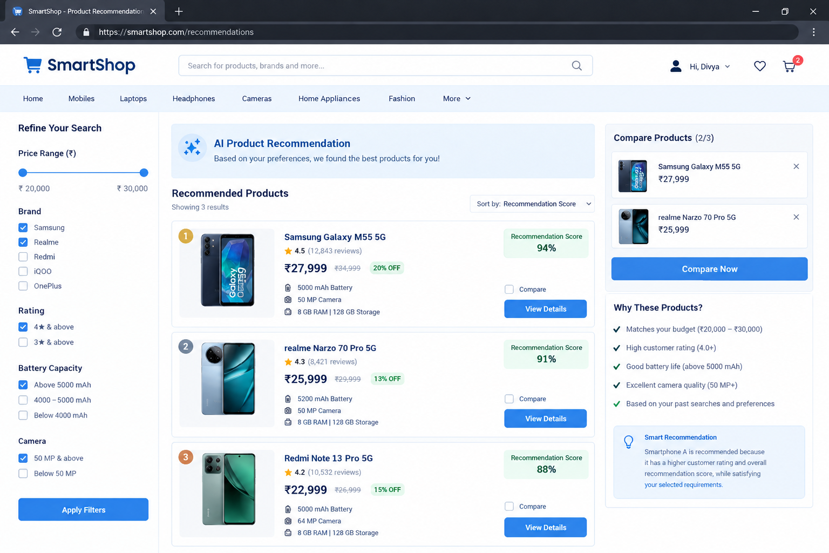

Rubrics for Calculation
Criteria | Excellent (5 Marks) | Good (3 Marks) | Satisfactory (2 Marks) | Needs Improvement (1 Mark)
Problem Understanding (30%) | Clearly explains the problem, objectives, and scope with complete understanding. | Explains the problem with minor omissions. | Basic understanding with limited explanation. | Poor understanding; objectives and scope are unclear or missing.
Stakeholder & Challenge Analysis (25%) | Identifies all stakeholders, their roles, and challenges with clear analysis. | Identifies most stakeholders and challenges with adequate analysis. | Identifies only a few stakeholders or challenges. | Stakeholders and system analysis are incomplete or inaccurate.
Current System Analysis (20%) | Thoroughly analyzes the existing system, strengths, weaknesses, and identifies all gaps. | Good analysis with most strengths and weaknesses identified. | Limited analysis with partial identification of issues. | Proposed solution is unclear or inappropriate; requirements are largely missing.
Proposed Software Solution & Software Engineering Principles (15%) | Proposes an innovative, feasible solution applying appropriate software engineering principles (modularity, scalability, maintainability, security, etc.). | Suitable solution with good application of software engineering principles. | Basic solution with limited application of software engineering principles. | Methodology is inappropriate, poorly justified, or not discussed.
Methodology/ Framework Justification (10%) | Selects the most suitable SDLC/model/framework and provides strong technical justification. | Suitable methodology selected with adequate justification. | Methodology selected but justification is weak. | Outcomes, limitations, or future enhancements are missing; report lacks organization and clarity.

Criteria | Mark
Problem Understanding (30%) | /5
Stakeholder & Challenge Analysis (25%) | /5
Current System Analysis (20%) | /5
Proposed Software Solution & Software Engineering Principles (15%) | /5
Methodology/ Framework Justification (10%) | /5
TOTAL | /25

